System Description (SysD) – Energy Forecast

**Abstract**

This document provides the main template for the System Description of Arrowhead compliant Systems. It should be used to define the main services and interfaces of a system, without describing its internal implementation.

All Arrowhead systems should be specified using this template and stored on a common repository (available on the SVN server), in order to document and formalize the pilot demonstrators and the common Arrowhead framework.

Table of Contents

Table of Contents 2

1. System Description Overview 2

2. Use-cases 2

3. Diagrams 3

4. Application services 3

4.1. Produced Services 3

4.2. Consumed Services 3

5. Security 3

6. References 3

7. Revision history 3

7.1. Amendments 3

7.2. Quality Assurance 3

1. System Description Overview

<<system>>

EnergyForecast

EnergyForecast

Outdoor

AuthorisationControl

ServiceDiscovery

Indoor

OrchestrationService

The energy forecast system provides forecast of the heat energy requirements of a building. Both the total amount of heat and the heat used solely for heating water is forecasted. Forecasting is based on previous consumption and temperatures (both indoor and outdoor). The system automatically updates its learning algorithm with new data from providers.

1. Behaviour Diagrams

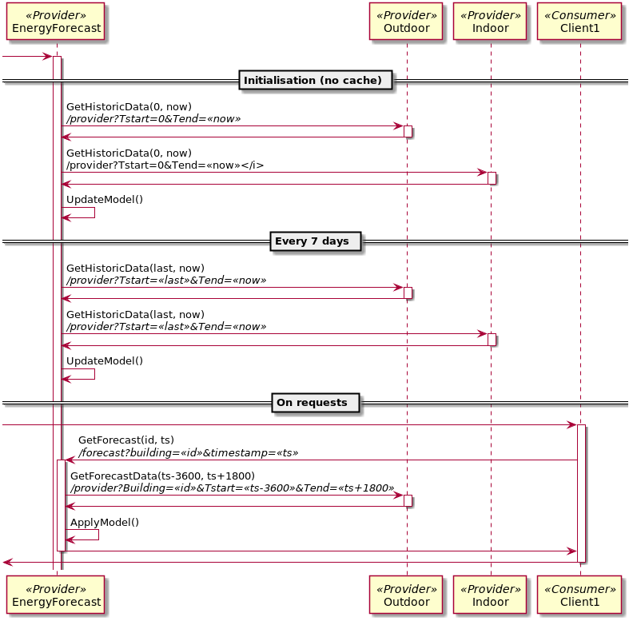

1. Application services

This section contains the Produced and Consumed services, which are described on a technology dependent Interface Design Description (IDD) document. An IDD accordingly specifies the details needed for implementation of service providers and consumers for a Service Description (SD) it refers to, appointing specific technology and semantics to be used and any interpretation, selection of parts, etc. – i.e. all details needed for plug and play.

# Produced Services

Table 2 Pointers to IDD documents

|  |  |
| --- | --- |
| Service | IDD Document Reference |
| EnergyForecast | IDD Interface Design Description – Energy Forecast.docx |

# Consumed Services

Table 3 Pointers to IDD documents

|  |  |
| --- | --- |
| Service | IDD Document Reference |
| Indoor | n/a |
| Outdoor | n/a |

1. Security

If the secure option is enabled the system will verify request against the Authorization system.

# Assets

The system stores three types of cache files:

Table 3 Assets

|  |  |
| --- | --- |
| File | Description |
| cacheX.csv | Historical data for building $X∈Z$. |
| cacheX.model | Prediction model for building $X∈Z$. |
| cache_ts.csv | Timestamp cache to get data incremental. |

1. References
2. Revision history

# Amendments

|  |  |  |  |  |
| --- | --- | --- | --- | --- |
| No. | Date | Version | Subject of Amendments | Author |
| 1 | 2017-09-18 | 0.1 | First draft | Thomas Pedersen |
| 2 | 2017-12-12 | 0.2 | Updated, according to Jerker’s comments. | Thomas Pedersen |
| 3 | 2018-05-29 | 0.3 | Updated to learning algorithm. | Thomas Pedersen |
| 4 | 2018-08-15 | 0.4 | Updated to Arrowhead 4.0 | Thomas Pedersen |

# Quality Assurance

|  |  |  |  |
| --- | --- | --- | --- |
| No. | Date | Version | Approved by |
| 1 |  |  |  |
| 2 |  |  |  |